Form C: Type Test Verification Report
All Micro-generators connected to the DNO Distribution Network shall be Fully Type Tested. This form is the Manufacturer’s declaration of compliance with the requirements of EREC G98.
This form should be used when making a Type Test submission to the Energy Networks Association (ENA)Type Test Register.
If the Micro-generator is Fully Type Tested and already registered with the ENA Type Test Register, the Installation Document should include the Manufacturer’s Reference Number (the system reference), and this form does not need to be submitted.
Manufacturer’s reference number |  |  | PROJOY20240409-M001
Micro-generator technology |  |  | PV Micro-inverter
Manufacturer name |  |  | Projoy Electric Co., Ltd.
Address |  |  | 2nd Floor Building, No.90 Chunyao Rd, Huangdai Town, Xiangcheng District, Suzhou, Jiangsu, China
Tel | +86-512-68786489 |  |  |  | Fax | \
E-mail | Marrow.huang@projoy-electric.com |  |  |  | Web site | www.projoy-electric.com
Registered Capacity, use separate sheet if more than one connection option. |  | Connection Option
 |  | 2.0 |  | kW single phase (PSOL-MS2000)
 |  | 1.8 |  | kW single phase (PSOL-MS1800)
 |  | 1.6 |  | kW single phase (PSOL-MS1600)
 |  | NA |  | kW single phase
 |  | NA |  | kW three phase
 |  | NA |  | kW two phases in three phase system
 |  | NA |  | kW two phases split phase system
Energy storage capacity for Electricity Storage devices |  | NA |  | kWh
Manufacturer Type Test declaration. - I certify that all products supplied by the company with the above Fully Type Tested reference number will be manufactured and tested to ensure that they perform as stated in this document, prior to shipment to site and that no site modifications are required to ensure that the product meets all the requirements of EREC G98.
Signed | 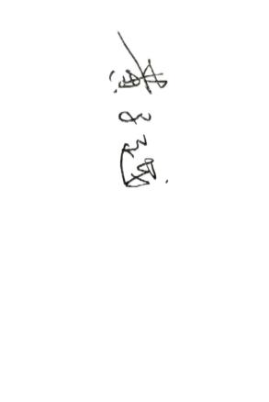 |  | On behalf of |  |  | Projoy Electric Co., Ltd.

Note that testing can be done by the Manufacturer of an individual component or by an external test house.
Where parts of the testing are carried out by persons or organisations other than the Manufacturer then that person or organisation shall keep copies of all test records and results supplied to them to verify that the testing has been carried out by people with sufficient technical competency to carry out the tests.
Operating Range: This test should be carried out as specified in A.1.2.10.
Pass or failure of the test should be indicated in the fields below (right hand side), for example with the statement “Pass”, “No disconnection occurs”, etc. Graphical evidence is preferred.
.
Test 1  Voltage = 85% of nominal (195.5 V)  Frequency = 47.0 Hz  Power factor = 1  Period of test 20 seconds | 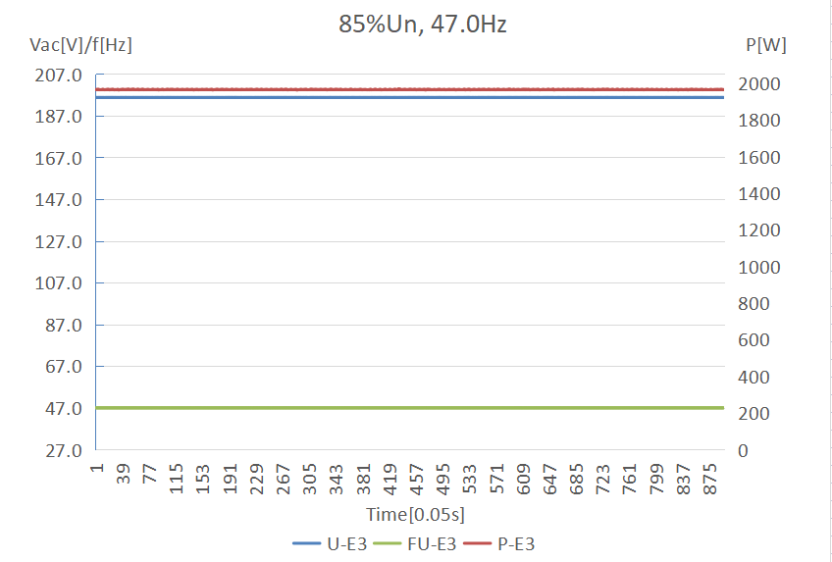
Test 2  Voltage = 85% of nominal (195.5 V)  Frequency = 47.5 Hz  Power factor = 1  Period of test 90 minutes | 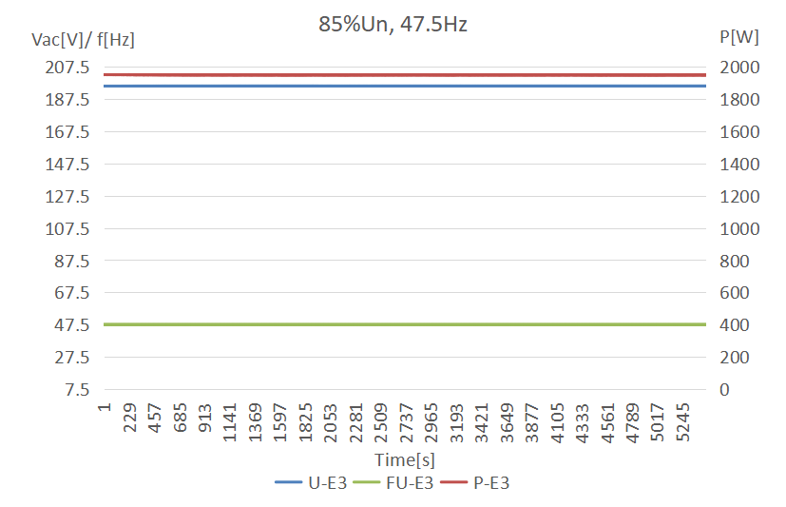
Test 3  Voltage = 110% of nominal (253 V).  Frequency = 51.5 Hz  Power factor = 1  Period of test 90 minutes | 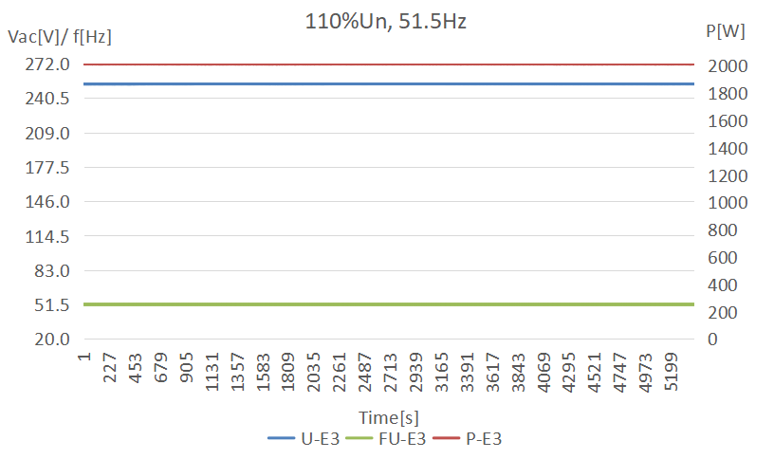
Test 4  Voltage = 110% of nominal (253 V).  Frequency = 52.0 Hz  Power factor = 1  Period of test 15 minutes | 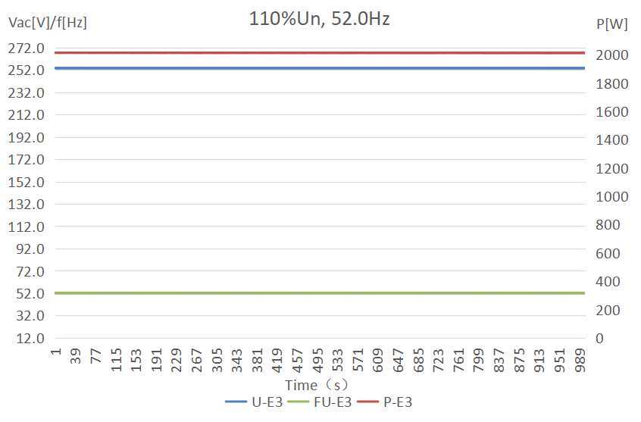
Test 5  Voltage = 100% of nominal (230 V).  Frequency = 50.0 Hz  Power factor = 1  Period of test 90 minutes | 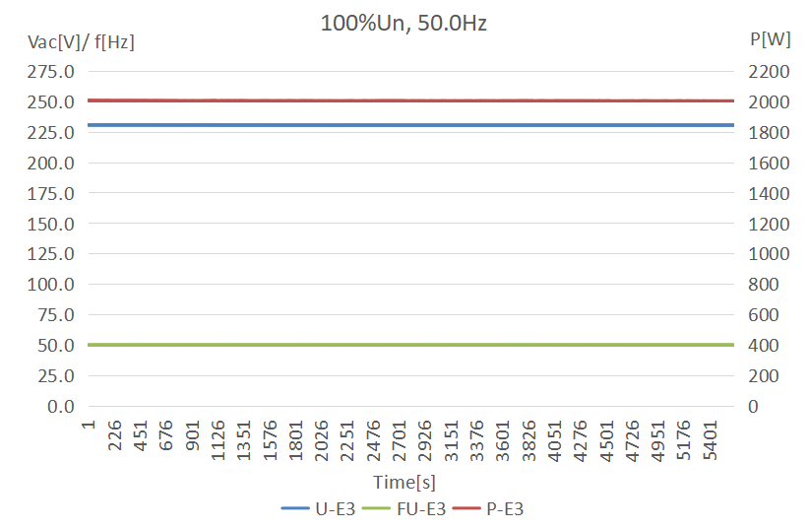
Test 6 RoCoF withstand  Confirm that the Micro-Generating Plant is capable of staying connected to the Distribution Network and operate at rates of change of frequency up to 1 Hzs⁻¹ as measured over a period of 500 ms. | 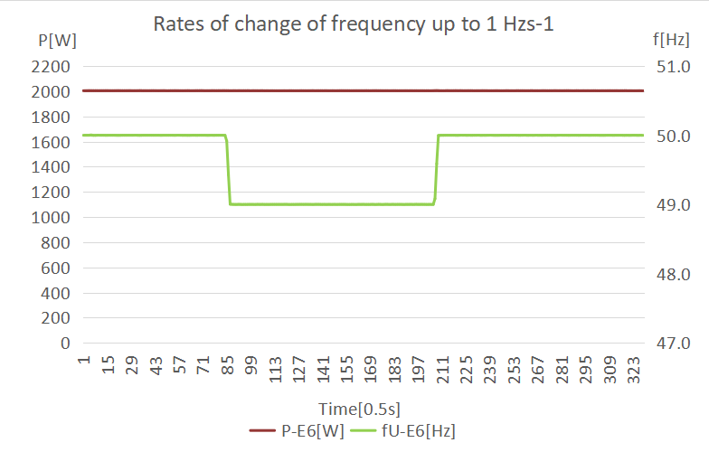

Power Quality – Harmonics: These tests should be carried out as specified in BS EN 61000-3-2. The chosen test should be undertaken with a fixed source of energy at two power levels a) between 45 and 55% and b) at 100% of Registered Capacity. The test requirements are specified in Annex A1 A.1.3.1 (Inverter connected) or Annex A2 A.2.3.1 (Synchronous).
Micro-generator tested to BS EN 61000-3-2
Micro-generator rating per phase (rpp) |  |  |  | 2.0 |  | kW | \
For 3-phase Micro-generators, tick this box if harmonic measurements are identical for all three phases. If the harmonics are not identical for each phase, please replicate this section with the results for each phase. |  |  |  |  |  | \
Harmonic | At 45-55% of Registered Capacity |  | 100% of Registered Capacity |  |  | \
 | Measured Value MV in Amps | Measured Value MV in percent | Measured Value MV in Amps |  | Measured Value MV inpercent | Limit in BS EN 61000-3-2 in Amps | Higher limit for odd harmonics 21 and above
2 | 0.00314 | 0.07106% | 0.00580 |  | 0.0665% | 1.080
3 | 0.08151 | 1.84698% | 0.12646 |  | 1.4501% | 2.300
4 | 0.00118 | 0.02677% | 0.00245 |  | 0.0281% | 0.430
5 | 0.03673 | 0.83234% | 0.14262 |  | 1.6355% | 1.140
6 | 0.00119 | 0.02694% | 0.00159 |  | 0.0182% | 0.300
7 | 0.04287 | 0.97132% | 0.09436 |  | 1.0820% | 0.770
8 | 0.00103 | 0.02336% | 0.00108 |  | 0.0124% | 0.230
9 | 0.02567 | 0.58164% | 0.05928 |  | 0.6798% | 0.400
10 | 0.00097 | 0.02208% | 0.00104 |  | 0.0119% | 0.184
11 | 0.02778 | 0.62961% | 0.02891 |  | 0.3315% | 0.330
12 | 0.00074 | 0.01668% | 0.00156 |  | 0.0179% | 0.153
13 | 0.01885 | 0.42709% | 0.02558 |  | 0.2934% | 0.210
14 | 0.00040 | 0.00911% | 0.00097 |  | 0.0112% | 0.131
15 | 0.02043 | 0.46288% | 0.02970 |  | 0.3405% | 0.150
16 | 0.00076 | 0.01725% | 0.00089 |  | 0.0102% | 0.115
17 | 0.02036 | 0.46137% | 0.04633 |  | 0.5313% | 0.132
18 | 0.00073 | 0.01653% | 0.00102 |  | 0.0117% | 0.102
19 | 0.02192 | 0.49662% | 0.04483 |  | 0.5141% | 0.118
20 | 0.00048 | 0.01088% | 0.00078 |  | 0.0090% | 0.092
21 | 0.01803 | 0.40863% | 0.03804 |  | 0.4362% | 0.107 | 0.160
22 | 0.00053 | 0.01190% | 0.00085 |  | 0.0098% | 0.084
23 | 0.00981 | 0.22238% | 0.01788 |  | 0.2050% | 0.098 | 0.147
24 | 0.00062 | 0.01397% | 0.00060 |  | 0.0068% | 0.077
25 | 0.01658 | 0.37578% | 0.01171 |  | 0.1343% | 0.090 | 0.135
26 | 0.00041 | 0.00924% | 0.00091 |  | 0.0105% | 0.071
27 | 0.01734 | 0.39281% | 0.01678 |  | 0.1924% | 0.083 | 0.124
28 | 0.00069 | 0.01553% | 0.00066 |  | 0.0075% | 0.066
29 | 0.01190 | 0.26962% | 0.02962 |  | 0.3397% | 0.078 | 0.117
30 | 0.00060 | 0.01357% | 0.00067 |  | 0.0077% | 0.061
31 | 0.00864 | 0.19574% | 0.03705 |  | 0.4248% | 0.073 | 0.109
32 | 0.00055 | 0.01234% | 0.00132 |  | 0.0151% | 0.058
33 | 0.01318 | 0.29866% | 0.03595 |  | 0.4123% | 0.068 | 0.102
34 | 0.00074 | 0.01682% | 0.00143 |  | 0.0164% | 0.054
35 | 0.01774 | 0.40197% | 0.02649 |  | 0.3038% | 0.064 | 0.096
36 | 0.00084 | 0.01909% | 0.00128 |  | 0.0147% | 0.051
37 | 0.01241 | 0.28126% | 0.01252 |  | 0.1436% | 0.061 | 0.091
38 | 0.00075 | 0.01695% | 0.00165 |  | 0.0189% | 0.048
39 | 0.00942 | 0.21334% | 0.01034 |  | 0.1186% | 0.058 | 0.087
40 | 0.00075 | 0.01696% | 0.00150 |  | 0.0172% | 0.046
Note the higher limits for odd harmonics 21 and above are only allowable under certain conditions, if these higher limits are utilised please state the exemption used as detailed in part 6.2.3.4 of BS EN 61000-3-2 in the box below.

Power Quality – Voltage fluctuations and Flicker: These tests should be undertaken in accordance with EREC G98 Annex A1 A.1.3.3 (Inverter connected) or Annex A2 A.2.3.3 (Synchronous).
Product Model |  | PSOL-MS2000 (TSOL-MS1800, TSOL-MS1600)
 |  | Starting |  |  |  |  |  | Stopping |  |  |  |  |  | Running
 |  | d(max) | d(c) |  | d(t) |  |  | d(max) |  | d(c) |  | d(t) |  | P_{st} |  | P_{lt} 2 hours
Measured Values at test impedance |  | 0.12% | 0.1% |  | 0 |  |  | 0.31% |  | 0.28% |  | 0 |  | 0.08 |  | 0.08
Normalised to standard impedance |  | 0.12% | 0.1% |  | 0 |  |  | 0.31% |  | 0.28% |  | 0 |  | 0.08 |  | 0.08
Normalised to required maximum impedance |  | - | - |  | - |  |  | - |  | - |  | - |  | - |  | -
Limits set under BS EN 61000-3-11 |  | 4% | 3.3% |  | 3.3% |  |  | 4% |  | 3.3% |  | 3.3% |  | 1.0 |  | 0.65
Test Impedance | R |  |  | 0.4 |  | Ω |  |  | X |  |  |  | 0.25 |  | Ω
Standard Impedance | R |  |  | 0.24 *  0.4 ^ |  | Ω |  |  | X |  |  |  | 0.15 *  0.25 ^ |  | Ω
Maximum Impedance | R |  |  | - |  | Ω |  |  | X |  |  |  | - |  | Ω
*Applies to three phase and split single phase Micro-generators.
^ Applies to single phase Micro-generators and Micro-generators using two phases on a three phase system.
For voltage change and flicker measurements the following formula is to be used to convert the measured values to the normalised values where the power factor of the generation output is 0.98 or above.
Normalised value = Measured value*reference source resistance/measured source resistance at test point.
Single phase units reference source resistance is 0.4 Ω
Two phase units in a three phase system reference source resistance is 0.4 Ω.
Two phase units in a split phase system reference source resistance is 0.24 Ω.
Three phase units reference source resistance is 0.24 Ω.
Where the power factor of the output is under 0.98 then the X to R ratio of the test impedance should be close to that of the Standard Impedance.
The stopping test should be a trip from full load operation.

Test start date |  | 2024-01-03 |  |  |  |  | Test end date |  |  |  | 2024-01-03
Test location |  | Projoy-Lab

Power quality – DC injection:This test should be carried out in accordance with A 1.3.4 as applicable.
The % DC injection (“as % of rated AC current” below) is calculated as follows:
% DC injection = Recorded DC value in Amps / base current
where the base current is the Registered Capacity (W) / 230 V. The % DC injection should not be greater than 0.25%.
Product Model | PSOL-MS2000 (PSOL-MS1800, PSOL-MS1600)
Test power level | 20% | 50% | 75% | 100%
Recorded DC value in Amps | 0.00782 | 0.00866 | 0.01114 | 0.00899
as % of rated AC current | 0.09% | 0.10% | 0.13% | 0.11%
Limit | 0.25% | 0.25% | 0.25% | 0.25%

Power Quality – Power factor: This test shall be carried out in accordance with A.1.3.2 and A.2.3.2 at three voltage levels and at Registered Capacity and the measured Power Factor must be greater than 0.95 to pass. Voltage to be maintained within ±1.5% of the stated level during the test.
Product Model | PSOL-MS2000 (PSOL-MS1800, PSOL-MS1600)
AC voltage | 216.46 V | 230.77 V | 253.87 V
Measured value | 0.999 | 0.999 | 0.999
Power Factor Limit | >0.95 | >0.95 | >0.95

Protection – Frequency tests: These tests should be carried out in accordance with Annex A1 A.1.2.3 (Inverter connected) or Annex A2 A.2.2.3 (Synchronous). For trip tests, frequency and time delay should be stated. For “no trip tests”, “no trip” can be stated.
Function | Setting |  | Trip test |  | “No trip tests”
 | Frequency | Time delay | Frequency | Time delay | Frequency /time | Confirm no trip
U/F stage 1 | 47.5 Hz | 20 s | 47.46 Hz | 20.2 s | 47.7 Hz  30 s | No trip
U/F stage 2 | 47 Hz | 0.5 s | 46.99 Hz | 0.534 s | 47.2 Hz  19.5 s | No trip
 |  |  |  |  | 46.8 Hz  0.45 s | No trip
O/F stage 1 | 52 Hz | 0.5 s | 52.02 Hz | 0.516 s | 51.8 Hz  120.0 s | No trip
 |  |  |  |  | 52.2 Hz  0.45 s | No trip
Note. For frequency trip tests the frequency required to trip is the setting ± 0.1 Hz. In order to measure the time delay a larger deviation than the minimum required to operate the projection can be used. The “No trip tests” need to be carried out at the setting ± 0.2 Hz and for the relevant times as shown in the table above to ensure that the protection will not trip in error.

Protection – Voltage tests: These tests should be carried out in accordance with Annex A1 A.1.2.2 (Inverter connected) or Annex A2 A.2.2.2 (Synchronous). For trip tests, voltage and time delay should be stated. For “no trip tests”, “no trip” can be stated.
Function | Setting |  | Trip test |  | “No trip tests”
 | Voltage | Time delay | Voltage | Time delay | Voltage /time | Confirm no trip
U/V | 184 V | 2.5 s | 182.1 V | 2.6 s | 188.73 V  5.0 s | No trip
 |  |  |  |  | 180 V  2.45 s | No trip
O/V stage 1 | 262.2 V | 1.0 s | 262.9 V | 1.0 s | 258.6 V  5.0 s | No trip
O/V stage 2 | 273.7 V | 0.5 s | 273.2V | 0.552 s | 269.7 V  0.95 s | No trip
 |  |  |  |  | 277.7 V  0.45 s | No trip
Note for Voltage tests the Voltage required to trip is the setting ±3.45 V. The time delay can be measured at a larger deviation than the minimum required to operate the protection. The No trip tests need to be carried out at the setting ±4 V and for the relevant times as shown in the table above to ensure that the protection will not trip in error.

Protection – Loss of Mains test: For PV Inverters shall be tested in accordance with BS EN 62116. Other Micro-generators should be tested in accordance with A.2.2.4 at 10%, 55% and 100% of rated power.
To be carried out at three output power levels with a tolerance of plus or minus 5% in Test Power levels.
Test Power | 10% |  | 55% | 100% | 10% |  | 55% | 100%
Balancing load on islanded network | 95% of Registered Capacity |  | 95% of Registered Capacity | 95% of Registered Capacity | 105% of Registered Capacity |  | 105% of Registered Capacity | 105% of Registered Capacity
Trip time. Limit is 0.5 s | 0.017s |  | 0.227s | 0.465s | 0.014s |  | 0.201s | 0.472s
Note for technologies which have a substantial shut down time this can be added to the 0.5 s in establishing that the trip occurred in less than 0.5 s. Maximum shut down time could therefore be up to 1.0 s for these technologies.
Indicate additional shut down time included in above results. |  |  |  |  |  | -
Additional comments:
-
For Inverters tested to BS EN 62116 the following sub set of tests should be recorded in the following table.
Test Power and imbalance |  | 33%  -5% Q  Test 22 | 66%  -5% Q  Test 12 | 100%  -5% P  Test 5 | 33%  +5% Q  Test 31 |  | 66%  +5% Q  Test 21 | 100%  +5% P  Test 10
Trip time. Limit is 0.5 s |  | 0.283s | 0.224s | 0.458s | 0.191s |  | 0.243s | 0.424s

Protection –Frequency change, Vector Shift Stability test:This test should be carried out in accordance with EREC G98 Annex A1 A.1.2.6 (Inverter connected) or Annex A2 A.2.2.6 (Synchronous). Confirmation is required that the Micro-generating Plant does not trip under positive / negative vector shift.
 | Start Frequency | Change | Confirm no trip
Positive Vector Shift | 49.0 Hz | +50 degrees | No trip
Negative Vector Shift | 50.0 Hz | - 50 degrees | No trip

Protection – Frequency change, RoCoF Stability test: The requirement is specified in section 11.3, test procedure in Annex A.1.2.6 (Inverter connected) or Annex A2 A.2.2.6 (Synchronous). Confirmation is required that the Micro-generating Plant does not trip for the duration of the ramp up and ramp down test.
Ramp range | Test frequency ramp: |  |  | Test Duration |  | Confirm no trip
49.0 Hz to 51.0 Hz | +0.95 Hzs⁻¹ |  |  | 2.1 s |  | No trip
51.0 Hz to 49.0 Hz | -0.95 Hzs⁻¹ |  |  | 2.1 s |  | No trip
Limited Frequency Sensitive Mode – Over frequency test: This test should be carried out in accordance with A.1.2.8. The test should be carried out using the specific threshold frequency of 50.4 Hz and Drop of 10%. The measurement tolerances are contained in A.1.2.8.
Test sequence at Registered Capacity>80% |  | Measured Active Power Output | Frequency |  | Primary Power Source |  | Active Power Gradient
Step a) 50.00 Hz ±0.01 Hz |  | 2004.9W | 50.00 Hz |  | 2132W |  | 2000W
Step b) 50.45 Hz ±0.05 Hz |  | 1988.3W | 50.45 Hz |  |  |  | 1980W
Step c) 50.70 Hz ±0.10 Hz |  | 1875.1W | 50.70 Hz |  |  |  | 1880W
Step d) 51.15 Hz ±0.05 Hz |  | 1677.6W | 51.15 Hz |  |  |  | 1700W
Step e) 50.70 Hz ±0.10 Hz |  | 1875.0W | 50.70 Hz |  |  |  | 1880W
Step f) 50.45 Hz ±0.05 Hz |  | 1987.5W | 50.45 Hz |  |  |  | 1980W
Step g) 50.00 Hz ±0.01 Hz |  | 2003.1W | 50.00 Hz |  |  |  | 2000W
Test sequence at Registered Capacity40% - 60% |  | Measured Active Power Output | Frequency |  | Primary Power Source |  | Active Power Gradient
Step a) 50.00 Hz ±0.01 Hz |  | 1003.55W | 50.00 Hz |  | 1075W |  | 1000W
Step b) 50.45 Hz ±0.05 Hz |  | 1003.19W | 50.45 Hz |  |  |  | 980W
Step c) 50.70 Hz ±0.10 Hz |  | 890.26W | 50.70 Hz |  |  |  | 880W
Step d) 51.15 Hz ±0.05 Hz |  | 693.08W | 51.15 Hz |  |  |  | 700W
Step e) 50.70 Hz ±0.10 Hz |  | 890.31W | 50.70 Hz |  |  |  | 880W
Step f) 50.45 Hz ±0.05 Hz |  | 1001.90W | 50.45 Hz |  |  |  | 980W
Step g) 50.00 Hz ±0.01 Hz |  | 1003.96W | 50.00 Hz |  |  |  | 1000W

Power output with falling frequency test: This test should be carried out in accordance with A.1.2.7.
Test sequence |  | Measured Active Power Output |  |  | Frequency |  | Primary power source
Test a) 50 Hz ± 0.01 Hz |  | 2001.6 |  |  | 50.00 Hz |  | 2135.6
Test b) Point between 49.5 Hz and 49.6 Hz |  | 2001.3 |  |  | 49.55 Hz |  | 2136.2
Test c) Point between 47.5 Hz and 47.6 Hz |  | 2001.8 |  |  | 47.55 Hz |  | 2135.9
NOTE: The operating point in Test (b) and (c) shall be maintained for at least 5 minutes
Re-connection timer.
Test should prove that the reconnection sequence starts after a minimum delay of 20 s for restoration of voltage and frequency to within the stage 1 settings of Table 2. Both the time delay setting and the measured delay should be provided in this form; both should be greater than 20 s to pass. Confirmation should be provided that the Micro-generating Plant does not reconnect at the voltage and frequency settings below; a statement of “no reconnection” can be made.
Time delay setting | Measured delay |  | Checks on no reconnection when voltage or frequency is brought to just outside stage 1 limits of table 2.
85s | 87s |  | At 266.2 V | At 180.0 V |  | At 47.4 Hz |  | At 52.1 Hz
Confirmation that the Micro-generator does not re-connect. |  |  | Not re-connect | Not re-connect |  | Not re-connect |  | Not re-connect

Fault level contribution: These tests shall be carried out in accordance with EREC G98 Annex A1 A.1.3.5 (Inverter connected) and Annex A2 A.2.3.4 (Synchronous). Please complete each entry, even if the fault contribution is zero.
For machines with electro-magnetic output |  |  | For Inverter output
Parameter | Symbol | Value | Time after fault | Volts | Amps
Peak Short Circuit current | i_{p} | NA | 20 ms | 79.44V | 3.51 A
Initial Value of aperiodic current | A | NA | 100 ms | 78.68 V | 3.78 A
Initial symmetrical short-circuit current* | I_{k} | NA | 250 ms | 77.70 V | 3.80A
Decaying (aperiodic) component of short circuit current* | i_{DC} | NA | 500 ms | 0V | 0A
Reactance/Resistance Ratio of source* | ^{X}/_{R} | NA | Time to trip | 0.346s | In seconds
For rotating machines and linear piston machines the test should produce a 0 s – 2 s plot of the short circuit current as seen at the Micro-generator terminals.
* Values for these parameters should be provided where the short circuit duration is sufficiently long to enable interpolation of the plot

Logic Interface (input port)
Confirm that an input port is provided and can be used to reduce the Active Power output to zero | Yes
Provide high level description of logic interface, e.g. details in 9.4.3 such as AC or DC signal (the additional comments box below can be used)  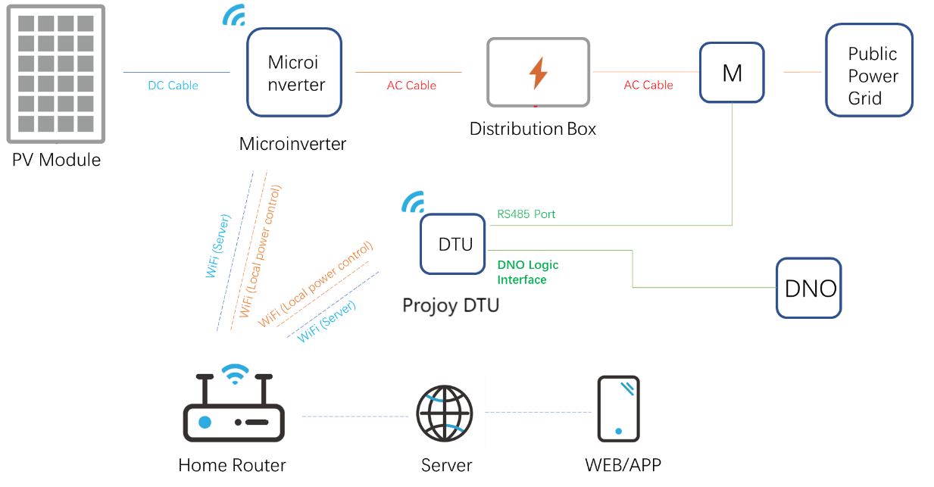  The Projoy microinverter can be controlled by the Projoy DTU device. The DNO logic interface is set on the DTU device and will take the form of a simple binary output that can be operated by the switch.  When the switch is turned off, the Microinverter and DTU can operate normally. When the switch is turned on, the DTU device will send control demand to the microinverter and the microinverter will reduce its Active Power to zero within 5 s.  The signal from the DTU device that is being switched is DC (maximum value 5Vdc). | Yes
Self-Monitoring solid state switching: No specified test requirements. Refer to EREC G98 Annex A1 A.1.3.6 (Inverter connected). | NA
It has been verified that in the event of the solid-state switching device failing to disconnect the Micro-generator, the voltage on the output side of the switching device is reduced to a value below 50 V within 0.5 s. | NA
Cyber security
Confirm that the Manufacturer or Installer of the Micro-generator has provided a statement describing how the Micro-generator has been designed to comply with cyber security requirements, as detailed in 9.7.  Projoy confirmed that MS2000 series microinverter and Monitoring Portal comply with cyber security requirements. | Yes
Additional comments

See the note in A.2.3.1 if 45-55% of Registered Capacity is below the minimum stable operating level. If an alternative loading level is chosen, the level should be indicated on the test form and the reason for not testing at 45-55% of Registered Capacity should be stated. The additional comments box at the end of the harmonics test sheet can be used for this.
See the note in A.2.2.4 if the suggested loading levels are below the minimum stable operating level. If alternative loading levels are chosen, the level should be indicated on the test form and the reason for not testing at 10%/55% of Registered Capacity should be stated. The additional comments box at the end of the loss of mains test sheet can be used for this.
If the device requires additional shut down time (beyond 0.5s but less than 1s) then this should be stated on this form.

